Final Project Design Phase
Computer Science - Week 11
Oct 3, 2026 - Version 0.0.4

For complete instructions and project ideas, refer to the assignment in Canvas. Specifically, review the final project requirements before you continue below. If you have not reviewed the project requirements in Canvas (you might have to go to the modules view and check the current or past week's content), you will not be able to properly complete the parts below. In addition, it may be helpful to review the information on this Drafter documentation page.

0) Project Planning and Preparation
Successful programmers spend time planning before they begin coding. After reviewing the project requirements, answer the following questions to help guide your design and development process.
- What concepts from class or previous assignments might help you complete this project? Which programming concepts (loops, conditionals, lists, classes, etc.) do you expect to use? What programming skills do you want to improve while completing this project?
I expect to use loops, if statements, routes, and pages. Also, dataclasses will most likely need to be created to organize assignment data from the user. I want to improve upon my skill of coding a larger program.

- Which parts of the project do you expect to be the easiest for you? The hardest? Why?
The easiest parts will be coding the individual sections. The hardest part will be the connecting of smaller sections of code into bigger programs, and ensuring they're accurate and run.

- Even though you have not yet designed the final project, estimate which tasks will likely require the most time and effort? Which features or components should be implemented first?
The feature of defining an assignment dataclass, and what details go into what an assignment is. Then, the parts requiring the most time will be creating functions to organize assignments how the user wants the information organized.

- What distractions might interfere with your work and how will you minimize them? What resources will you need available while working? What questions, if any, do you still have about the assignment requirements?
Distractions will be other homework, assignments, and exams for this class and other classes. I have the resource of talking to TA's and using the discord if I need help with questions.

1) Site Diagram
Create a mock-up of your planned website. We suggest you make the mockup on paper, although you can also use software like PowerPoint or Slides to make a mockup. There is other design software that could also be used, but we strongly encourage you to keep it simple. Do not spend more than 15-30 minutes detailing the mock-up. Your goal should be to make a very quick and dirty diagram, to show that you have some kind of idea.

We recommend drawing each page as a rectangle, and laying out the text, buttons, and other components inside. Then, use arrows to indicate links between pages. Label each page the way you will name each function, and then put labels on the arrows to indicate what the button links. Also write down any parameters that should come into the pages.

In addition to the pages and routes, write down what fields your `State` will have, both their names and types. Think clearly about what data will need to be persistent across the entire website.

Add photo(s) or screenshot(s) of your website mock-up and labeled diagram on the next page.

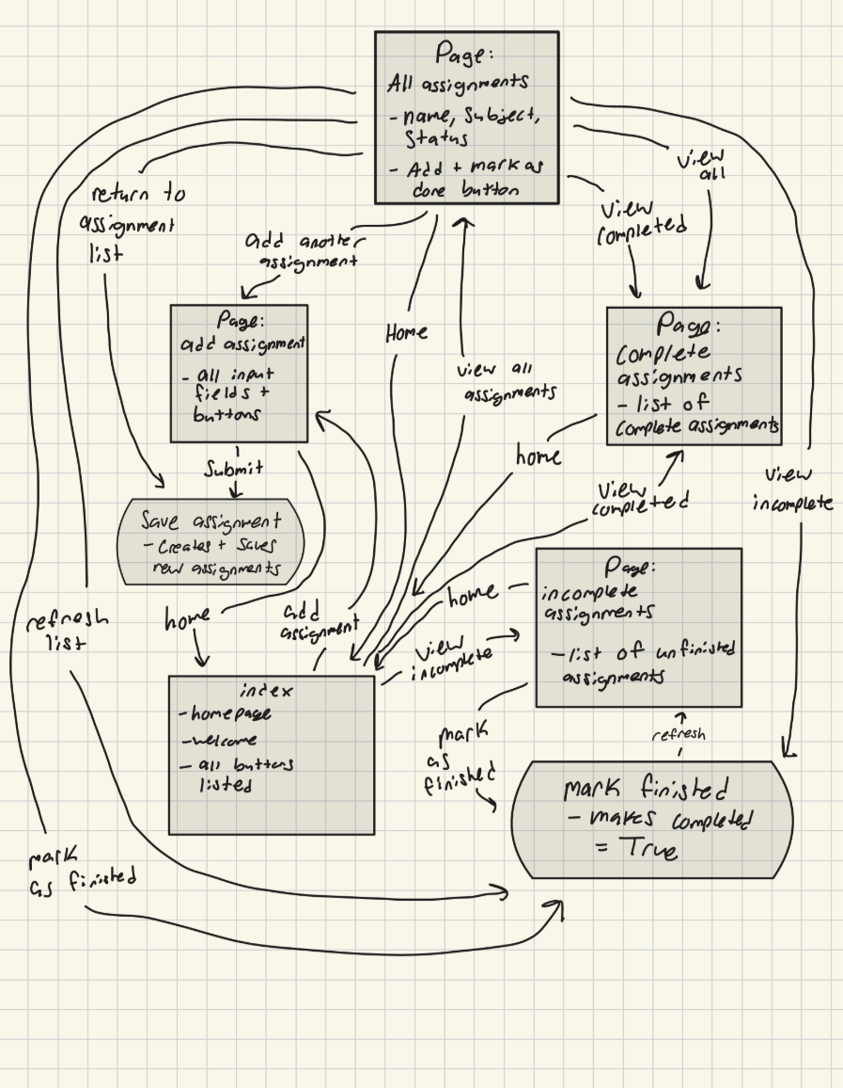
2) Implementing Requirements
This table should serve as a draft for how you will implement the requirements into your final project. You may change your ideas later on, but your final site must fulfill all the requirements.

Requirement | Implementation
Purpose/Functionality  A 1-2 sentence description of the purpose or functionality of your site | I will create an assignment tracker for students, with the key features of, an input field to enter a homework assignment, a list showing the assignments entered, and a button to mark an assignment as finished.
State Dataclass Attributes  Minimum of 4 attributes, one of which must be a list/dict of instances of your second dataclass.  Briefly describe each attribute, its type, and how it will be meaningfully modified throughout the site. | assignments - type: list[Assignment]  Stores all the homework assignments entered by the user. Each new assignment will be entered to the list to keep track of the data. Assignments will be removed from the list when marked as complete  new_assignment - string  This temporarily stores each new assignment name right after the user enters it into the input field.  page_title - string  This will store the title of the current page. This will change as the user changes between pages of the website.  show_completed - boolean  This will determine if the assignment should be shown to the viewer. This will filter completed and uncomplete assignments.
Second Dataclass  Your second dataclass, including its attributes, their types, and how they will be meaningfully modified (if they are modified) | Dataclass name: Assignment  This will store information about each individual assignment.  name - string  This stores the name of each individual assignment  completed - boolean  This marks whether the assignment has been completed for not. False is incomplete, True is completed.  subject - string  This stores the subject related to the assignment that the user selects.
Routes (minimum 7)  The names of your route functions | index - displays the homepage of the website  add_assignment - displays the page where the user can add a new homework assignment into the input field  save_assignment - saves the homework assignment entered by the user and inputs it into the assignments list  view_assignments - displays all of the assignments currently stored in the list from the user input.  mark_finished - changes once the user changes the assignments completed status from False to True  view_incomplete - displays only the incomplete assignments  view_complete - displays only the completed assignments
Pages (minimum 5)  A brief description of the pages in your site | Home Page - the main page of the website.  Add Assignment Page - Contains the input field where the user can input their assignments and select its subject.  All Assignments Page - Where a list of all the assignments are located.  Incomplete Assignments Page - A page where only a list of uncompleted assignments are located  Completed Assignments - A page where only a list of completed assignments are located
User Input (minimum 3)  Description of user input components (TextBox, TextArea, CheckBox, or SelectBox) and their purposes  For more information on these input types, see Drafter Documentation. | TextBox - Allows the user to input the name of the assignment.  SelectBox - Allows the user to select which subject the assignment belongs to.  CheckBox - Allows the user to select whether the assignment is incomplete or complete  Button - Mark As Finished - Will turn an assignment from incomplete to complete
If Statements (minimum 3)  Brief description of what will be evaluated in your if statements and how they will meaningfully change the logic of the site | Check for empty assignments - Checks whether the user inputs an assignment name. If it is left empty, the website will display an error message.  Check completion status - Checks whether an assignment's completed attribute is True or False. Displays whether the assignment is finished or unfinished  Check assignment filter - Checks whether the user wants to view incomplete or completed assignments. Determine switch assignments should appear on the page.
Loop (minimum 1)  This loop must iterate over the list/dict of dataclass instances in your State attribute.  Description of this loop and why it is meaningful to the site | For loop  Literates through the assignments list in the State dataclass. For each assignment, the loop displays its name, subject, and completion status on the all assignments page.

LLM Conversation
If you used an LLM in any part of this work, copy and paste every part of that conversation below. Otherwise, you may be given a zero for the assignment. Obviously, these words will not all be yours, and this is the exception to the requirement at the top of this assignment that all responses be in your own words. If you did not use an LLM to assist you in this assignment, simply say so below.
Me:
I am trying to create a table draft of my python code project. my project goal is I will create an assignment tracker for students, with the key features of, an input field to enter a homework assignment, a list showing the assignments entered, and a button to mark an assignment as finished. Create me a table draft of this code with these features:

LLM:

For your assignment tracker, I recommend keeping the project relatively simple since it is for an introductory Python coding class. You can use two dataclasses: one to store the overall website information and another to store individual homework assignments.
Here is a table draft that meets all the minimum requirements while keeping your project manageable.
1. State Dataclass Attributes
Attribute | Type | Description and how it will be modified
assignments | list[Assignment] | Stores all homework assignments entered by the user. New assignments will be added to this list, and assignments will be updated when marked finished.
new_assignment | str | Temporarily stores the assignment name typed into the input field. Updated whenever the user enters a new assignment.
page_title | str | Stores the title of the current page. Changes depending on which page the user visits.
show_completed | bool | Determines whether completed assignments should be displayed. Changes when the user selects the completed assignments filter.
2. Second Dataclass
Dataclass name: Assignment
This dataclass will store information about each individual homework assignment.
Attribute | Type | Description and how it will be modified
name | str | Stores the name or description of the homework assignment. Entered by the user and does not normally change.
completed | bool | Tracks whether the assignment has been finished. Starts as False and changes to True when the user marks it finished.
subject | str | Stores the school subject associated with the assignment (such as Math, English, or Science). Selected by the user when adding an assignment.
3. Routes (Minimum 7)
These are the names of the route functions that will control navigation and actions throughout your website.
Route Function | Purpose
index | Displays the homepage and welcomes the user to the assignment tracker.
add_assignment | Displays the page where users can enter a new homework assignment.
save_assignment | Saves the homework assignment entered by the user into the assignments list.
view_assignments | Displays all assignments currently stored in the list.
mark_finished | Changes an assignment's completed status from False to True.
view_incomplete | Displays only assignments that have not been completed.
view_completed | Displays only assignments that have been marked finished.
4. Pages (Minimum 5)
Page | Description
Home Page | The starting page of the website. Includes a welcome message and navigation buttons to other pages.
Add Assignment Page | Contains an input field where users can type in a homework assignment and select its subject.
All Assignments Page | Displays a list of every assignment entered by the user, including whether each is finished or unfinished.
Incomplete Assignments Page | Displays only homework assignments that have not been marked finished.
Completed Assignments Page | Displays homework assignments that the user has already finished.
5. User Input (Minimum 3)
Input Component | Purpose
TextBox | Allows the user to type the name or description of a homework assignment.
SelectBox | Allows the user to select the subject of the assignment, such as Math, English, Science, or History.
CheckBox | Allows the user to select whether an assignment is completed or unfinished. Can be used to update the assignment's completion status.
You will also have a Mark as Finished button next to each assignment. Clicking this button will change the assignment's completed attribute to True.
6. If Statements (Minimum 3)
If Statement | What it evaluates and how it changes the website
1. Check for empty assignments | Checks whether the user entered an assignment name. If the input is empty, the website will display an error message instead of saving the assignment.
2. Check completion status | Checks whether an assignment's completed attribute is True or False. Displays whether the assignment is finished or unfinished.
3. Check assignment filter | Checks whether the user wants to view completed or incomplete assignments. Determines which assignments should appear on the page.
7. Loop (Minimum 1)
Loop | Description and purpose
For Loop | Iterates through the assignments list in the State dataclass. For each assignment, the loop displays its name, subject, and completion status on the All Assignments page. It can also check whether an assignment is completed and display a Mark as Finished button next to unfinished assignments.
8. How the website will work
Here is a simple example of how the different parts will work together:
Step 1: Add an assignment
Assignment name
Complete math homework
Subject
Math
Add Assignment
Step 2: View assignments
My Assignments
2 assignments
Complete math homework
Math · Incomplete
Unfinished
Read English chapter 3
English · Completed
Finished
Step 3: Mark an assignment finished
Complete math homework
Marked as Finished!
My recommendation: Start with these features rather than adding more complicated functions like due-date calendars, reminders, or accounts. Your three main features (adding assignments, displaying assignments, and marking assignments finished) are enough to create a useful website and demonstrate important Python concepts such as dataclasses, lists, loops, conditionals, and functions.
One important note: Your seven routes are route-function ideas, not necessarily seven completely separate pages. Some routes perform actions, such as saving an assignment or marking it finished, rather than displaying a new page.

Final Submission
When you are finished, download this file as a Word Document (docx) and upload the file to the appropriate assignment on Canvas.

